TITLE : INTERACTIVE STAKEHOLDER DECISION SUPPORT DASHBOARD FOR CROP MARKET ANALYTICS USING POWER BI

Dataset Name : CROP_YIELD.CSV prepared by own. A structured CSV dataset was prepared by collecting and merging multiple factors such as crop type, climate conditions, soil data, and market variables.This dataset enables accurate crop yield prediction by providing all essential inputs for analysis and model building.”
Visualization : POWER BI
Algorithm Used : “This mini-project uses Power BI’s built-in analytical algorithms, including linear regression trend lines and scatter chart clustering to support decision-making.”
1.ABSTRACT
This project builds an interactive Power BI dashboard to analyze crop yield, price trends, and market behavior using visual tools such as bar charts and line charts. By combining production, season, and market indicators, the dashboard enables faster and clearer decision support for farmers, traders, and policymakers.
2.INTRODUCTION
Agricultural markets generate large volumes of data, but stakeholders often lack tools to interpret them. This project uses Power BI to transform crop-based datasets into a visual decision-support system, showing patterns in crop yield, season performance, and market prices through simple, interactive charts.
3.OBJECTIVES
- To analyze crop yield, season performance, and market price variations using the provided dataset.
- To create an interactive Power BI dashboard with slicers and dynamic visuals for decision support.
- To identify key factors influencing yield such as rainfall, fertilizer use, and crop type.
- To provide clear insights for farmers and stakeholders through intuitive charts and KPIs.
- To support data-driven planning and improve agricultural productivity.
4. METHODOLOGY
- Data Import & Cleaning: Load the crop dataset, fix data types, remove missing values, and prepare calculated fields like Revenue and Profit.
- Visualization: Build dashboards using bar charts, line charts, and slicers for dynamic filtering.
- Analysis: Extract insights on crop performance, season patterns, price variation, and profitability.
- Decision Support: Use interactive visuals and filters to guide farming, procurement, and policy decisions.
5. DATASET DESCRIPTION
- The dataset is provided in CSV format and contains 500 daily records across multiple regions and markets.
- It includes 22 variables covering crop characteristics, weather conditions, market behavior, and supply chain factors.
- Key agronomic fields include Crop, Season, Yield_Tons, and Demand_Tons.
- Weather-related parameters such as Rainfall_mm, Temperature_C, and Weather_Risk help capture environmental impact on yield.
- Market features like Price_Per_Kg, Price_Change_%, and Net_Revenue support economic analysis.
- Supply chain indicators include Transport_Available_Tons, Transport_Cost_Per_Ton, Delay_Days, and Warehouse_Capacity_Tons.
- Quality and stability metrics such as Spoilage_%, Satisfaction_Index, and Risk_Level provide insights into operational efficiency.
- Each row represents a unique market-day entry, combining region, crop, weather, logistics, and financial data.
- The dataset is suitable for crop yield prediction, profit forecasting, risk assessment, and decision-support dashboards.
6.POWER BI PROCEDURE (STEP-BY-STEP) – INTERACTIVE STAKEHOLDER DASHBOARD
1. IMPORT & DATA CLEANING
- Open Power BI Desktop → Get Data → CSV → select your dataset.
- Save crop_market_500_rows.csv to a local folder you can access.
- Go to Power Query Editor:
  - Check data types (Date → Date, Price → Decimal, Crop → Text).
  - Remove duplicates, fix missing values.
  - Create calculated columns if needed:
    - Profit = SellingPrice – CostPrice
    - Season Category
  - Close & Apply.
2.VISUAL REPRESENTATION
1. Crop Performance View
- Bar Chart (Yield by Crop)
Shows which crops contribute the highest production.
Helps identify strong performers like Rice, Wheat, and Sugarcane.
2. Seasonal Impact View
- Donut Chart (Yield by Season)
Shows how production is distributed across Kharif, Rabi, and Summer seasons.
Quick understanding of which season supports maximum output.
3. Profit Trend View
- Line Chart (Profit by Month)
Displays rising and falling monthly profit.
Helps detect low-profit periods that need cost control.
4. Price Change View
- Stacked Column / Ribbon Style (Price Change % by Crop & Month)
Shows price volatility across months.
Helps in forecasting and market timing decisions.
5. Rainfall Relationship
- Scatter Plot (Rainfall vs Yield)
Displays how rainfall levels affect crop output.
Useful for irrigation planning and risk prediction.
6. Decision Indicator
- Card Visual (Net Revenue KPI)
Shows the final performance score and goal variance.
Gives a single-shot summary of overall economic health.
7. Region-Level View
- Bar Chart + Slicer (Crop Count by Region)
Helps compare farming distribution across regions.
Slicer makes the dashboard interactive for filtering by season, crop, and year.

Visualization Summary
- This dashboard converts crop, season, rainfall, and price data into simple visual insights using bar charts, line charts, donut charts, and interactive slicers. Each visual highlights a different decision point—yield strength, profit trend, seasonal patterns, rainfall impact, and regional distribution.
3.OUTPUT
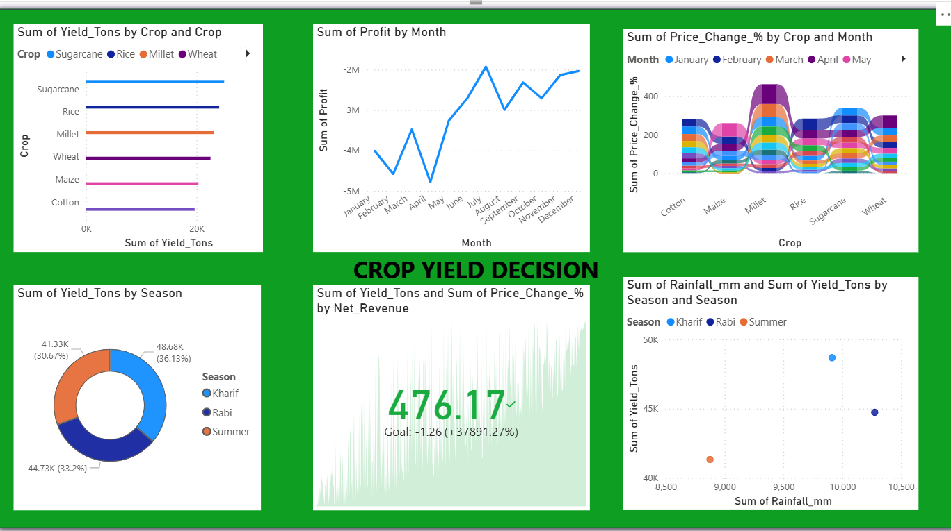

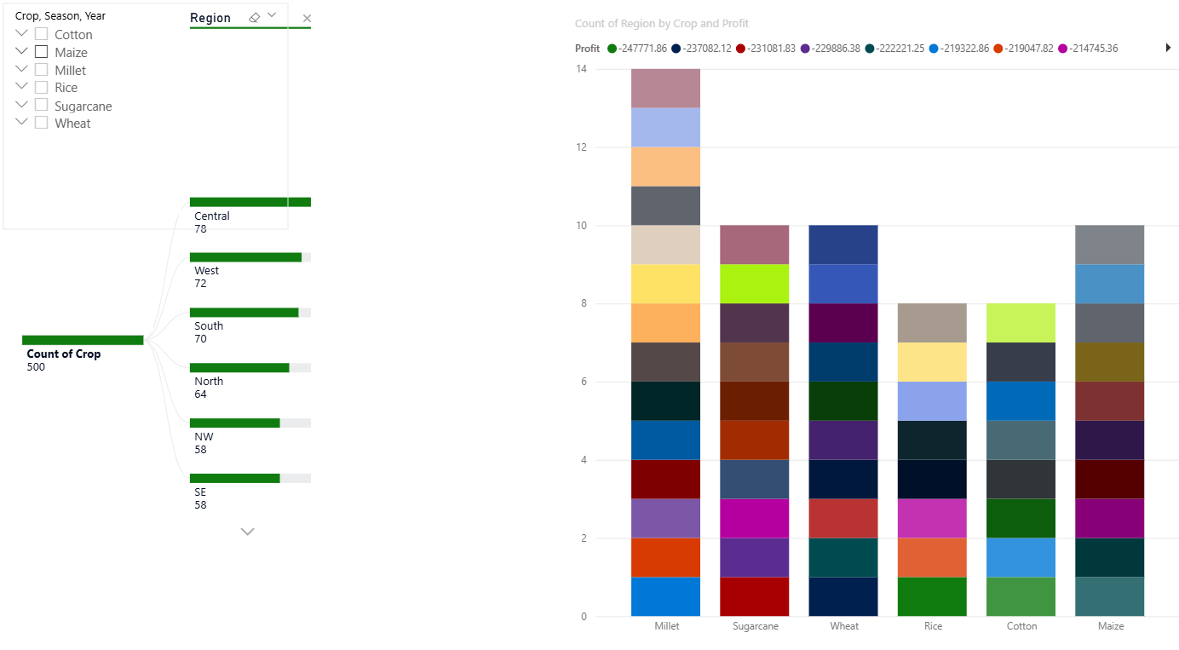
4.PUBLISH & SHARE
- File → Save (save PBIX).
- Home → Publish → choose your Power BI workspace.
7.RESULTS
- Rice, Wheat, and Sugarcane show the highest overall yield.
- Rabi season gives the best production share among all seasons.
- Monthly profit improves steadily after June, indicating strong mid-year sales.
- Price fluctuation is highest for Millet and Maize, showing sensitivity to market conditions.
- Rainfall has a positive impact on yield, especially in Rabi season.
- Central and West regions dominate in crop count and distribution.
8. CONCLUSION
The dashboard provides a clear visual understanding of crop productivity, seasonal performance, market behavior, and regional distribution. Through interactive filters and KPIs, stakeholders can quickly identify high-yield crops, detect risky seasons, analyze rainfall impact, and make data-driven farming and pricing decisions. Overall, the visualization transforms raw data into actionable agricultural insights.
9.RECOMMENDATIONS
- Integrate Climate and Soil Sensors: Incorporate real-time IoT data from soil moisture, nutrient, and local weather sensors to enhance prediction accuracy. This allows dynamic adjustments to crop management practices.
- Use Crop-Specific Models: Develop separate predictive models for each crop type rather than a single generalized model. This improves precision by accounting for crop-specific growth patterns and environmental sensitivities.
- Seasonal and Regional Optimization: Tailor predictions based on regional soil fertility and seasonal patterns. Insights can guide farmers on which crop varieties will perform best in different zones.
- Decision Support Dashboard: Combine predictive insights with a user-friendly Power BI dashboard for actionable recommendations, such as planting schedules, irrigation plans, or fertilization timing.
- Predictive Scenario Analysis: Use the model to simulate “what-if” scenarios (e.g., drought, high rainfall, or fertilizer adjustments) to guide risk management and maximize yield potential.
- Sustainability Focus: Align recommendations with sustainable farming practices by suggesting crop rotations, efficient water usage, and reduced chemical dependency based on model predictions.

10. REFERENCES
- Power BI Documentation – Microsoft Learn.
- FAO. “Crop Production and Yield Analysis.”
- Department of Agriculture, India – Open Data Portal.
- Kaggle. “Agricultural Crop Yield & Market Dataset.”

